ANNUAL PARISH MEETING 2023
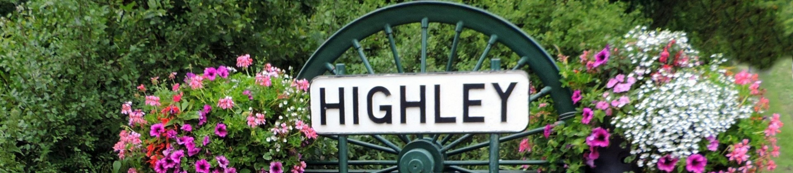  Highley Parish Council |  | TUESDAY 2nd MAY 6-7pm will be held at The Severn Centre, Highley. Agenda as follows:  - Apologies for absence  - Minutes from 2022  - Peter Vinall, Chairmans Report from Highley Parish Council  - Edward Andrews from Severn Valley Country Park  - Eileen Moore- from Highley Companions  - Lisa Delmar- from The Shed  - Emma Aspin (Carter)- Highley Community Project
Tuesday 2nd May, 6-7pm
The Severn Centre, Highley, WV16 6JG

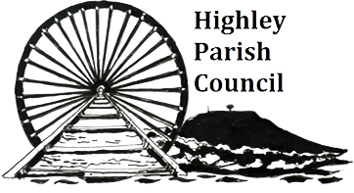 |  | Highley parish council  Highley Parish Council Office, The Severn Centre, Highley, WV16 6JG  07496821159 |clerk@highleyparish.co.uk | www.highleyparish.co.uk

