HIGHLEY ANNUAL PARISH MEETING was held at the Severn Centre Highley, on Tuesday the 26th April 2016

The Chairman of the Parish Council, Mr. M.Brooks took the Chair. There were 9 Parish Councillors, 1 Shropshire Councillor and 1 members of the Public present.

APOLOGIES: Parish Councillors M.Phipson, J.Law

MINUTES OF PREVIOUS MEETING: These were accepted on the proposal of Mr. Thakrar, seconded Mr. Marshall.

MATTERS ARISING FROM MINUTES: No comments.

PARISH COUNCIL CHAIRMANS REPORT

Road Safety Schemes – Crossing upgraded at Ashleigh Gardens, New Lights installed at crossing in village centre. The Parish Council have also asked for Shropshire Council to consider a 20mph scheme in Redstone Drive by Highley Primary School
New Crossing point due to be installed during this financial year below the Severn Centre.

Castle Inn – Parish Council have asked Shropshire Council to look at the condition of the Castle Inn. A Section 77 Dangerous Structure Notice has been issued. Some of The Chimneys have been removed when damaged by the storms. A section of the wall has been taken down and the windows and doorways have been boarded up. The Empty Homes Team at Shropshire Council are pursuing the owners (one point two ltd) to do something about the building awaiting a response from Shropshire Council to this

Highley remembers its Military Hero’s – event held with the Arrow Valley Brass Band and The Bewdley Players in November. Very successful, funds raised for Highley Pool and Help for Hero’s. Many thanks must go to Mandy Burgess and Helen Heeley. Ella Preston, Liz Brooks and the Severn Centre who helped make this event successful. It is hoped to hold another event again this year featuring the Military Wives Choir. 5. Calendars/Christmas Cards – The Highley Calendar and Christmas Cards were a success this year, raising funds for the Refurbishment of the Swimming Pool. The Parish Council are arranging for another Calendar for 2017. The Theme this year is “Old Highley”. If anyone has any photographs of Highley’s past please send them to the Clerk of the Parish Council.

New Bus Shelters – The Parish Council are to replace all the Bus Shelters in the village over the coming financial year. The metal ones are to be replaced with Wooden Shelters, more in keeping with a village environment.

Summer Pride – Highley Summer Pride Organisation has decided to disband this year. Please be assured that there will be floral displays in the village. The Parish Council are working with the Severn Centre Grounds Maintenance Team to provide the displays. The colour theme for this year is Red/White/Blue in honour or the Queens 90th Birthday. I would like to thank Chris Reeves, the Severn Centre Manager who has worked hard to help us arrange these display’s at such short notice.
The Parish Council were sorry to see the Summer Pride disband, these were a small group of committed volunteer who worked tirelessly to provide floral display’s to brighten up our village. I would like to thank them on behalf of the Parish Council for all their excellent work.

Grants – This year Highley Parish Council have given grants to the following
Highley Scout and Brownie Hut Refurbishment
Highley Walking Football Club
Severn Centre – Children’s Summer Activities
Royal British Legion – Poppy Appeal
Highley Summer Swimming Club
Bridgnorth Crime Prevention Panel – Crucial Crew Event (Highley School Children)

The Clerk and I attended a meeting with Malcom Pate and officers from Shropshire Council in February of this year. At this meeting we were informed that in the next Financial year, as those of you who attended the recent Local Joint Committee meeting will be aware, Shropshire Council are proposing major cuts to the Recreation and Leisure Services. In Highley this will include the Severn Centre/Library and other green space areas. The Parish Council will be working with Shropshire Council and our other partners such as The Severn Centre, to look at other ways to fund these services.

I would like to thank all Parish Councillors for their support this year. I would also like to thank Shropshire Councillor D.Tremellen for his work on behalf of the village.

SEVERN CENTRE REPORT

Pool update & Maintenance works;

The funding for the pool is continuing well, we have currently raised £22,500 largely from local donations and businesses which is greatly appreciated.

Grant funding, we have been accepted into the second stage of the leader fund and continue to work hard to put the project into a good position to be successful in obtaining the funds.

We have also submitted the application to inspired facilities and currently waiting for news – fingers crossed. My thanks have to go you Vick Turner, Shropshire Councils Community engagement officer and Ella Preston Clerk of the Parish Council; both have worked tirelessly in helping to submit the applications.

Shropshire star tokens, I would like to thank everybody for participating in collecting the tokens, I would particularly like to thank Barbra Steel for her efforts in collecting approximately 5,000 token! This year we have collected around 1,000 more tokens so I hope we will come in the top 3 this year.

Pool Maintenance

Works have commenced in preparation for the new pool season to identify where the pool is losing approximately £3,000 of water per year.

Previous die tests has been carried out to identify where the leak is which concluded that the tank is structurally ok, this indicated to issues in the pipe works in the return flow (From the deep end to the plant room)

The pipes have since been pressure tested which indicated substantial cracks that needs to be addressed in order to open the pool this year.

The pictures below shows the work in progress, the first picture shows the poolside dug up and the second picture shows a return pipe installed along with a skimmer valve and pool vac pipe works which were de commissioned when the centre was built for unknown reasons.

The trench for the pipe was dug out by Taylor Whimpey free of charge and the dig to 2.9m was done by Shropshire Plant and haulage (Ashley Barry). Without this help the pool may ran the risk of having a delayed opening (potentially not at all – thank you!

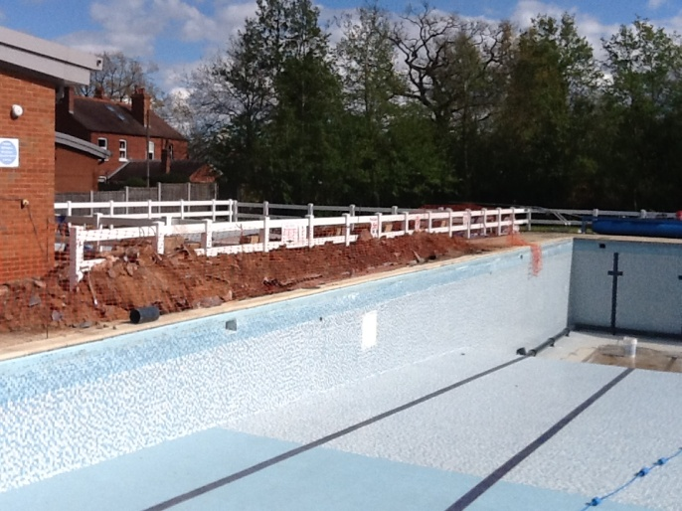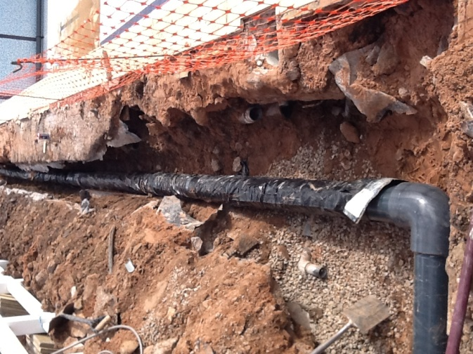

This year the centre has been doing some detailed work on the water charges for Severn Trent (ST) to reduce the cost; the current cost is £9,000. With our findings (ST) was challenged to the banding we were in.
ST have since been to site to inspect and agreed to reduce the banding, this will reduce our expenditure by around £2,000 for the financial year

Further works is been carried out on the drainage of the facilities (Storm water) if we can prove to ST that the storm water does not enter ST drainage system we can possibly further reduce the billing by a further £7,000 per year. This may mean investigating the possibilities of utilizing a soak away should the water enter the drainage system.

If local residents can help in understanding the drainage in particular the field please don’t hesitate to contact the centre.
SHROPSHIRE COUNCILLORS REPORT

Let’s not kid ourselves, this year’s 3.9% increase in Council tax will not bring in enough money to relieve the growing pressure on the services Shropshire Council is legally obliged to continue to provide, such as caring for the elderly and disabled, maintaining children’s services and collecting the rubbish – all the services that form the basic requirements of a civilized society.

Whilst 1.9% of that 3.9% increase was the maximum increase allowed to the basic rate without a local authority having to hold a referendum, the other 2% was the “social care precept”, needed to cover the shortfall in Council funding caused by the extra responsibility passed to local authorities with the Care Act, the impact of which no one could gauge because no one knew what the financial implications would be. They were significant.

Even the predicted £372 million that that 2% social care precept is expected to raise will not come anywhere near to being enough to meet the costs of the social care services as now constituted, but because responsibility for the delivery of those services has passed to local authorities, “blame” for any shortcomings in delivery will now be blamed on local authorities.

Adding insult to injury, that extra £372 million will possibly have to be spent covering the cost to councils of introducing the Government’s National Living Wage because it has been estimated that it could cost at least £330 million to cover the higher wage costs to providers of home care and residential care.

As I pointed out in an earlier report to council, previous years of keeping council tax as low as possible will mean that when the process of running down the system of revenue support that used to come from central government begins to hit (and front-loaded at that, with the largest hit in the first year), Shropshire Council could ﬁnd itself having to ask residents to pay more council tax to offset the spiralling cost of social care in 2016/17.

Highley parish council will have the job of warning its community that despite the hike in council tax, the quality and quantity of services on offer could drop as the income will not be enough to offset the full impact of further funding reductions in following years, with the National Living Wage bringing a signiﬁcant further cost pressure.

Vulnerable members of our community will face an uncertain future because social care services will increasingly be unable to help ease the growing pressure on the NHS, whose own existence is under threat.

Shropshire Council will still be seriously short of funding, even after Council tax rises, despite the assumed future growth in business rates, which Shropshire’s rurality with a preponderance of small businesses, many of whom will now be exempt from business rates anyway, will be lucky to see anything of any significance from.

Despite all the positive spin about growth in the economy from central government and our local MPs, the fact remains that the revenue support grants that used to come back locally to councils will not in future be shared out across the board but shifted to give a greater hit to shire counties, already under the greatest pressure because of the problems of delivering services to an ageing population across greater distances than the favoured urban authorities.

That extra 2% every year for social care in no way covers even basic needs. Shire authorities like Shropshire that provide social care have been the worst hit in the funding settlement, testing resident’s faith in us when we’re forced to raise taxes to replace the Revenue Support Grant. As if that wasn’t enough, we’re going to be forced to make further serious cuts just to survive. Whilst central government may have promised not to raise taxes, they very cleverly said nothing about forcing local councils to do so.

Communities Secretary Greg Clarke (who visited Shropshire two weeks ago) introduced some new funding that partly – only partly - corrects the disadvantage felt by shire counties in the (provisional) local government ﬁnance settlement, but whilst Shropshire got an additional £8 million this year, it was immediately swallowed up covering the shortfall in our social care budget.

What you won’t have had pointed out is that, unlike the NHS, social care is not protected, and the living wage, whilst commendable, is not funded.

I didn’t become a councillor to argue against reductions in much needed services, let alone finding myself fielding questions from constituents about appalling road maintenance, a total lack of local economic development and worrying about statutory services like rubbish collection being extended from two weeks to three.

I despair at councils being forced to fund the extension of the right to buy to the sale of affordable housing from housing associations, sales which local authorities will have to raise the funds to compensate the housing associations for by selling off their own social housing. Meanwhile, councils are still expected to meet increasing demands from more people in housing need.

On which note, we need to be aware that at the back end of 2016 preliminary work will start on the next round of the Site Allocations and Management of Development (SAMDev) for Shropshire, which is why we need to seriously consider our options because much of the future funding available for communities will be tied to a community’s willingness to accept development.

Resist as you might, all the indications are that central government’s tightening of the screws will be driven by their determination to force through their housing policies no matter what, the blackmail of funding being conditional on the willingness to accept housing development, blackmail presented as “reward” for compliance. No houses, no money.

If anyone doubts the government’s determination to push those policies they need only note recent reports that show just how prepared Westminster is to open up sizeable areas of Green Belt to the developers.

Where does that leave us in Highley? We need at least to review the options and consider whether we sit and watch as the developers come in anyway on the back of government policy, or decide that if it is inevitable we have a say in the what and the where in order not to find ourselves having to lie back and think of England regardless without getting paid for our pains.

TOPIC FOR DISCUSSION – SHROPSHIRE COUNCIL CUTS AND THE EFFECTS THIS WILL HAVE ON HIGHLEY

Chair M.Brooks gave details of the proposed cuts and the effects this could have on Highley. He said that as of the financial year 2016/17 Shropshire Council were no longer going to fund Leisure, Community Services and village maintenance. This could make in the region of £100,000.00 to Highley. The majority of the shortfall would before services carried out at the Severn Centre. He said that Shropshire Council expected the Town and Parish Councils to pick up the shortfall.

Shropshire Councillor David Tremellen explained about the difficult financial situation at Shirehall as per his report above.

Concern was expressed by parishioners about the amount of funding given to Highley for road repairs and safety improvements. Councillor Tremellen stated that the situation would only get worse due to the settlement given to Shropshire Council from Central Government.

PARISHIONERS TIME

Comments received regarding the lack of attendance by parishioners at the meeting. Parish Council to look at other ways of holding the meeting for next year.

SIGNED......................................................................DATE:

