Come and join us to meet and discuss our community. The event will be attended by:
- Phillip Dunne MP
- Highley School Choir performance at 10am
- Shropshire Council
- Highley Parish Council plus- Environmental Working Party and Communications Group
- Fire Service
- Police- bike and tool marking and Smartwater, community concerns local policing team
- Community Wellbeing Team
- Highley Community Project
- Highley First Responders
- Marches Energy
- Rural Shropshire Needs ambulances campaign group
- First Responders
- Halo group, plus activity try outs and demos
- West Midlands Ambulance Service
- Bob the Mobile clinic- public heath
- The Shed
- Highley Parish Church
And more!

Highley community

open day

- Highley Neighbourhood Watch
- Healthwatch
- Highley Medical Centre
- Severn Centre Minors Café will be open!
And Much More!
Saturday 21st May 2022 between 10am-1pm

Severn Centre, Highley, WV16 6JG

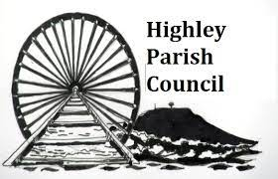

HIGHLEY PARISH COUNCIL
Bridgnorth Road, Highley, Nr. Bridgnorth WV16 6JG
01746 861979 | clerk@highleyparish.co.uk | www.highleyparish.co.uk

