Recycling & Rubbish

What is Fly Tipping
Fly-tipping is the illegal dumping of any waste or rubbish (greater than a single sack) anywhere other than at a licenced tip.
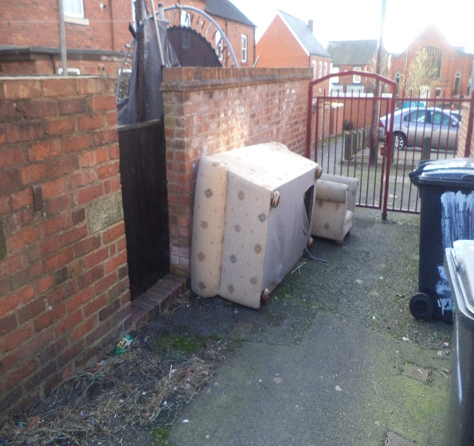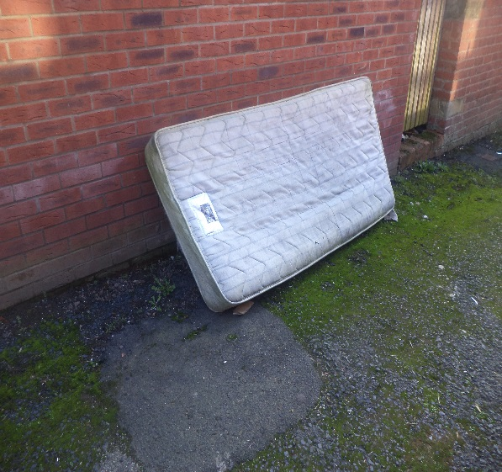

Why is Fly Tipping a Problem?
Fly-tipping is dangerous and potentially harmful, while also spoiling our environment, attracting arson and further fly-tipping. As council tax payers, cleaning it up costs us all money.

I Have Notice Some Fly Tipping – How Can I Get it Removed?
Phone 0345 678 9006, with a description of the waste, and a good description of the location (using descriptions of permanent landmarks or address of property).

I have Witnessed Someone Fly-tipping Waste – What Can I Do?
Phone 0345 678 9006. The Council will require dates, times and locations, a description of the person dumping waste, their vehicle (registration number, colour, make, model), and whether the person was approached. With sufficient information, we can write the person a warning letter, or bring them in for questioning under caution. The Council can investigate all fly-tipping on both public and private land, with the landowner's consent.

Contact
customer.service@shropshire.gov.uk
0345 678 9006

Bulky waste
If you have large / bulky items which are too big for your bin, rather than throw them away you could get someone local to collect them for free simply by offering them as 'free to a good home' on the Freegle website at www.freegle.org.uk/.
Another alternative for having them collected is to offer to donate them to your local furniture re-use scheme.

How to re-use furniture
If you have unwanted furniture or electrical items, don’t dump them, donate them! The Council work closely with several local charities and social enterprises who can collect your items and reuse them in the local community.
What items do they want?
- Furniture
- Electrical items
- Bedding
- Curtains
- Crockery and cutlery
- Anything you would need for starting up a new home
All schemes prefer items in working order but can make basic repairs. To arrange a collection please contact your local furniture scheme directly:
- Shrewsbury Furniture Scheme (Home Essentials) Tel: 01743 246668
- Telford Furniture Scheme (Chairs & Spares) Tel: 01952 619197
- Oswestry and North Shropshire Furniture Scheme (Shropshire Housing Alliance)Tel: 01691 679817
- South Shropshire Furniture Scheme Tel: 01584 877788
- Shropshire Community Project Tel: 07792 369201
- British Heart Foundation Tel: 01743 355673
- Revive Tel: 01743 588458
You can take large / bulky items of household waste to one of the Council’s household recycling centres free of charge.
Shrewsbury Household Recycling Centre
Vanguard Way
Battlefield Enterprise Park
Shrewsbury
Shropshire
SY1 3TG
Bridgnorth Household Recycling Centre
Faraday Drive
Bridgnorth
Shropshire
WV15 5BA
Alternatively if you want to have it collected you can pay to use the Council’s bulky waste collection service.

Bulky waste collection service

What the Council can't collect
The Council only collect bulky household waste that can be safely lifted by two people. They won't collect:
- Business waste
- Garden waste
- Clinical waste
- Hazardous waste
- Construction and demolition waste
- Soil and rubble
- Fixtures and fittings
- Pianos
- Safes
- Garden sheds
- Storage heaters

Book a collection
Phone the Council on 0345 678 9007. They'll take your payment and then their sub-contractor (a local charity working in waste management to train people disadvantaged in the labour market) will ring you back to book a collection time.

Cost per collection
Number of items to be collected | Price
1-3 | £30
4-6 | £45
7-9 | £60
10-12 | £74
13-15 | £90
1-10 sacks of general rubbish | £46

